Creating Microservices for account and loan:
Implementation Steps – Creating Microservices for Account and Loan
- Create a Microservices folder inside the IdeaProjects directory. This folder is used to store both microservice projects.
- Open Spring Initializr and create a Maven project for the Account Microservice. Use com.cognizant as the Group and account as the Artifact. Add the Spring Boot DevTools and Spring Web dependencies. Generate, download, and extract the project into the Microservices folder.
- Open the Account project in IntelliJ IDEA and create an AccountController class inside the com.cognizant.account.controller package. Annotate the class with @RestController. Create a GET API using @GetMapping("/accounts/{number}"). Use @PathVariable to receive the account number and return dummy account details such as account number, type, and balance.
- Run the Account application. By default, it starts on port 8080. Test the API using http://localhost:8080/accounts/00987987973432 and verify the JSON response.
- Create another independent Maven project using Spring Initializr for the Loan Microservice. Use com.cognizant as the Group and loan as the Artifact. Add Spring Boot DevTools and Spring Web. Download and extract the project into the same Microservices folder.
- Create a LoanController inside the com.cognizant.loan.controller package. Use @RestController and create a GET API using @GetMapping("/loans/{number}"). Use @PathVariable to receive the loan number and return dummy loan details such as loan number, type, loan amount, EMI, and tenure.
- Since the Account Microservice is already using port 8080, configure the Loan Microservice to use port 8081 by adding server.port=8081 to application.properties.
- Run both applications simultaneously and test the Loan API using http://localhost:8081/loans/H00987987972342. Both independent microservices now run successfully on different ports.

Screens that show that the “Account” application has started and is working;
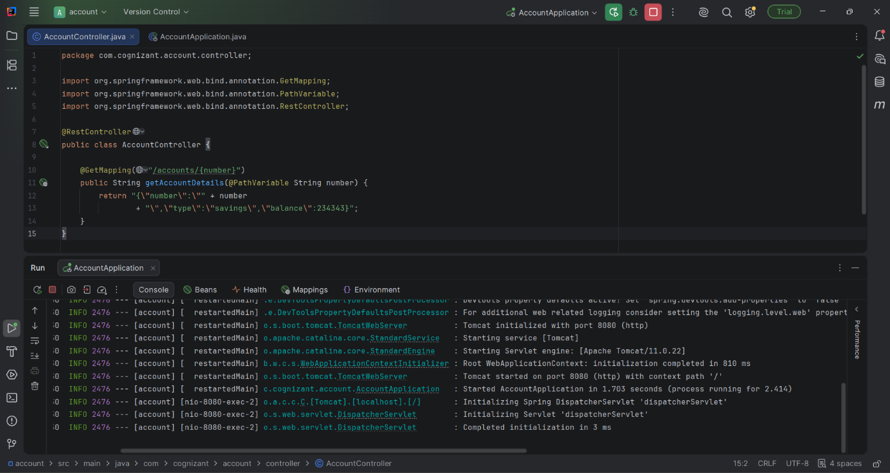

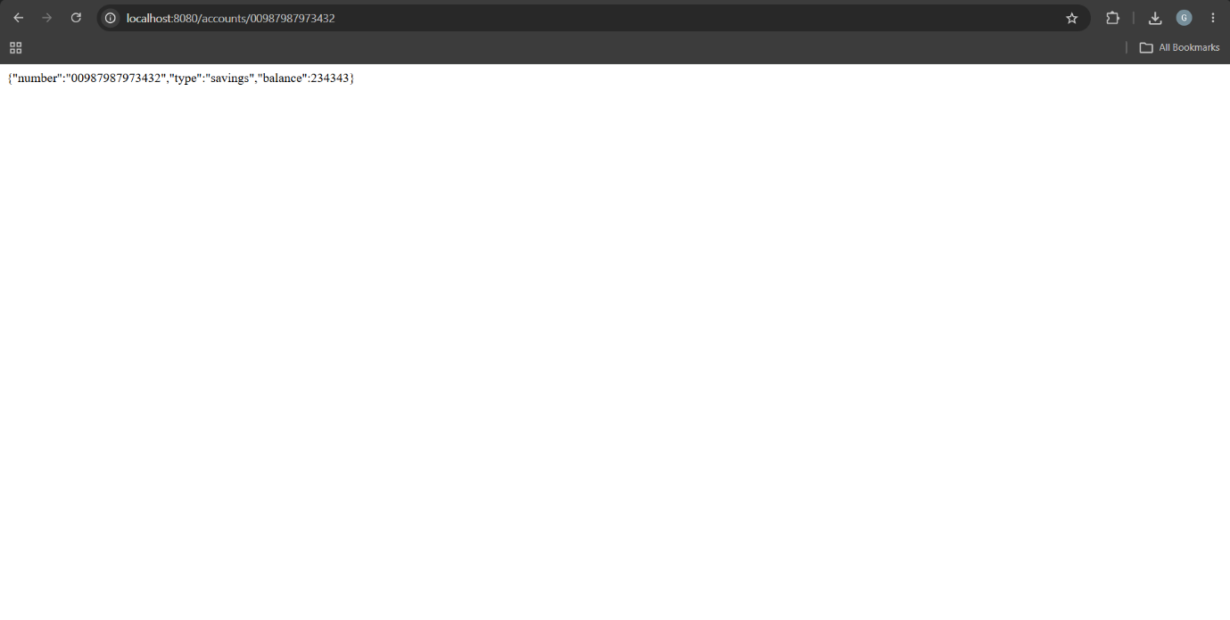

Screens that show that the “Loan” application has started and is working;
